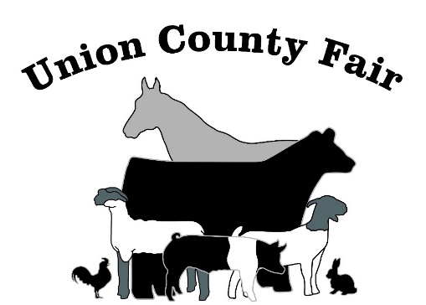
Union County Fair
August 10, 11, 12, & 13, 2022

**ALL TIMES SUBJECT TO CHANGE**

***RULES may have changed PLEASE review categories***

August 3, 2022
Families to set up for Fair @ 8 AM

August 10, 2022 (Wednesday)
6:00 am Fair barn Open
8:00 am ALL livestock and horse in place
9 am to 10am ALL INSIDE EXHIBITS (Tin Barn) will be checked in
8:15 am Weigh and classify.
*Steers will start followed by pigs/ sheep/goat.
*Weigh & Scan Production Steers immediately following weigh in of all livestock
10:00 am All Rabbit/Poultry/Water Fowl in place.
10am to 5 pm Tin Barn Closed for Judging and setting up displays.
4:00 pm Project Horse Show Judging
5:00 pm Doors open to exhibition -tin barn.
11:00 pm Fair barn closes – everyone must exit barn

August 11, 2022 (Thursday)
6:00 am Fair barn Open
9:00 am Judging Breeding & Market Sheep
10:30 am Judging Meat Goats- 1 hour after sheep show
6:00 pm Judging Market Swine
Old timers show immediately following swine show
11:00 pm Fair barn closes – everyone must exit barn

August 12, 2022 (Friday)

6:00 am Fair barn Open
9:00 am Rabbit Judging
9:30 am Poultry Judging
10:30 am NSWCD Ranch Management Contest
3:00 pm Judge Production Steer
4:00 pm Open Breeding Show (subject to change pending entries)
5:00 pm Bucket Calf Contest
5:30 pm Judging Jr Breeding Cattle & Dairy
6:00 pm Judging Market Steers/Market Heifers
11:00 pm Fair barn closes – everyone must exit barn

August 13, 2022 (Saturday)
6:00 am Fair barn Open
9:00 am Queen Contest
1:00 pm Junior Pet Show (livestock show ring) TBA
7 AM-12 PM NON-SALE animal’s release
3:00 pm Production Steer Result Meeting at Livestock Show Ring
3 – 3:30 pm Check out Exhibits
3:30 pm Exhibit Barn Closes to exhibit check out
4:00 pm Buyers Meal
5:45 pm Small Awards Program
6:00 pm Junior Livestock Sale
11:00 pm Fair barn closes – everyone must exit barn

August 14, 2022 (Sunday)
Families to tear down fair pens & clean up @ 9 AM
*****************************************
Buckles, Banners, and Showmanship Awards will be handed out during individual show.
A running slide show in eating area will list winners.

Online DEADLINE: August 1, 20212
**************************
Union County Fair Board Association
PO Box 29
Clayton, NM 88415
**************************************
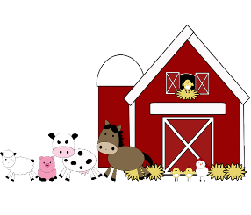
Peddlers’ Market – FRIDAY AND SATURDAY

